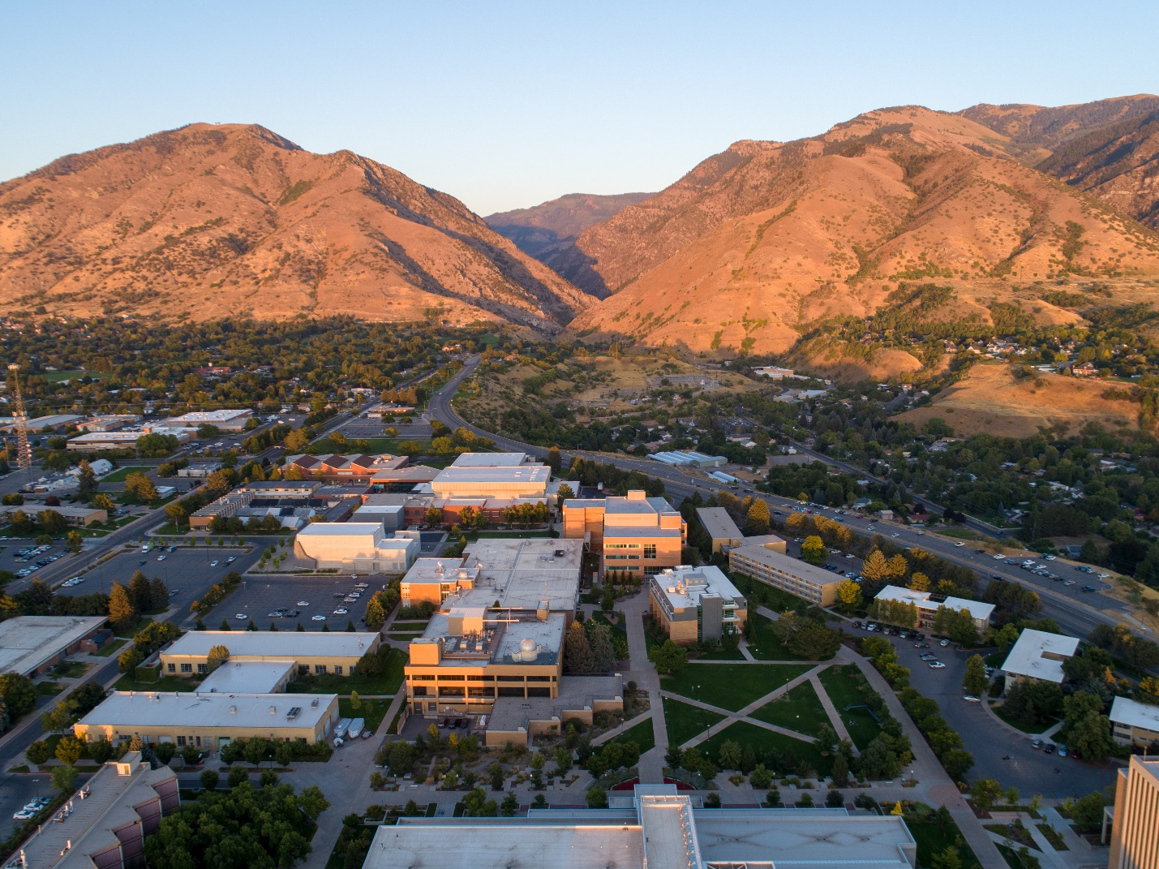

**Milestone M.2 Progress ReporT**

Performance Period #

No. # | March 17, 2021

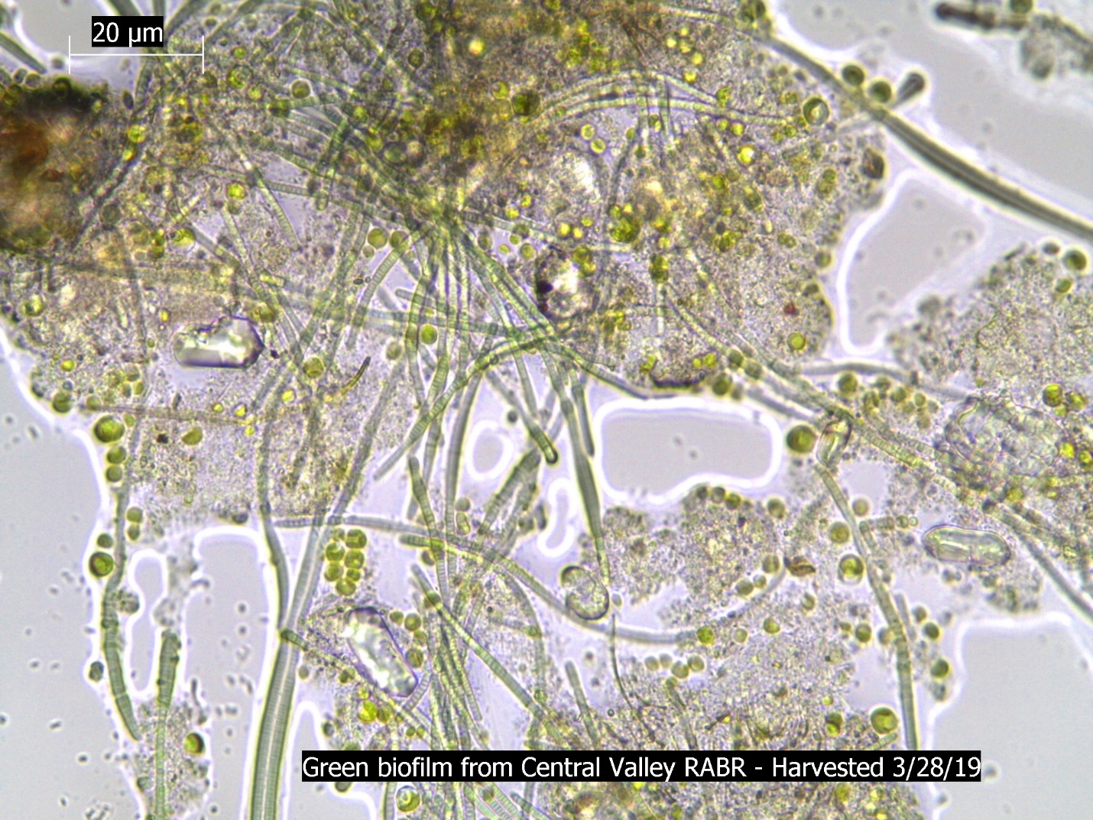

Award DE-EE0009271

Report Contributors

|  |  |  |
| --- | --- | --- |
| Name | Organization | Position |
| Ronald Sims | Utah State University | Principal Investigator |
| Dylan Ellis | Utah State University | Graduate Research Assistant |
| Jacob Watkins | Utah State University | Graduate Research Assistant |
|  |  |  |
|  |  |  |

Project Collaborators







Table of Contents

Introduction 1

Project Description 1

Project Progress 1

Pilot-Scale Rotating Algae Biofilm Reactor 1

Biofilm Community Composition 1

Project Financial Status 2

Problems Encountered 2

Conclusion 2

References 3

Appendix A - Example 4

# Introduction

As always, first indicate the **purpose of the report** and its intended audience. Clearly define the **time period covered** in the report (see also titles). Then, explain the project’s objectives and summarize the major issues. This is ideally no more than 3-5 sentences.

# Project Description

Readers familiar with the project can skip this section. Someone unfamiliar with the project, however, needs summarized details such as purpose and scope of the project, start and completion dates, and names of parties involved [1]. Often this section can be adapted from a proposal or borrowed from a previous progress report.

# Project Progress

This is the substance of the report (so “summary” may be a misnomer). You want to discuss work done, work in progress, and work to be done. You might just use these as subheadings to structure the section. This would be a project-tasks approach. Other approaches are time-periods or a combined approach. There are three main ways to approach this area:

**Project-tasks Approach:** Focus on the tasks. Defined milestones can logically organize your discussion into this kind of structure. Also, if you are working on a number of semi-independent tasks at the same time, this approach will work well.

**Time-periods Approach:** Focus on time: the previous period, the current period, the future. If a timeline (or deadline) is more important than milestones, then use this approach. Also, use it for projects with a simple linear structure.

**Combined Approach (recommended):** The two above approaches could be combined if, for example, under previous work, you break down what you have done by individual tasks. Or, under the tasks, you focus on what part is complete, what part is in progress, and what part is yet to come.

Your project (and sometimes your sponsor) will determine which of these three you use. If the problems encountered or changes required are time-related, then use the time-periods approach to your advantage; likewise, if the problems or changes relate to specific tasks then use the project-tasks approach. Another item that may be included here is a summary of financial data. This last item could be contained in a table or appendix, or an independent section.

Below are some sections that could also be included in addition to breaking down progress by project topic.

## Pilot-Scale Rotating Algae Biofilm Reactor

Add details and photos about setup.

## Biofilm Community Composition

Add details and photos about progress.

## Project Financial Status

# Problems Encountered

As noted in the opening, snags are expected. Don’t hide from them; explain what they are and how they might affect key areas of the job (such as timing, price or quality). If the problem occurred in the past, you can explain how you overcame it. This is least serious; in fact, you look good. If the problem is in front of you (now or in the future), explain how you hope to overcome it, if you can.  If changes are a direct result of problems encountered write about each problem and the change it requires in the project.

# Conclusion

Since a progress report is not about a finished work, the conclusion needs only to give your professional opinion of how the project is going. Being unrealistically optimistic is as inappropriate as being unduly negative. Beware of promising early completion: a single setback can gobble up much time. Likewise, don’t overreact if you are behind schedule. You may also gain time along the way. Far more significant for the engineer is to explain anything that may change the expected quality of the final product. Keeping in mind your purpose can help you focus here: your goal is to enable the manager or sponsor to make informed decisions.

# References

Choose a reference style early on and use it in every progress report.

# Appendix A - Example

In a short report (less than 10 pages) keep appendices to a minimum. It is always appropriate, however, to lodge financial data in an appendix if it does not fit elsewhere in the report. An important guideline is that it is only worth including an appendix if you mention it in the guts of the report. Otherwise, leave it out altogether. This would be a good place for tables of data from which only the conclusions are mentioned in the main body of the report.